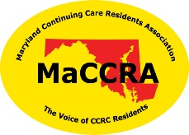 | Maryland Continuing Care Residents Association  Chapter Dues Transmittal Form

To: MaCCRA State Treasurer
Stephen U. Harders
717 Maiden Choice Lane, Apt. 305
Catonsville, MD 21228-6125
suharders@gmail.com
(410) 565-6283

Date: ______________________
Name of Chapter: ___________________________________________
Collected for this transmittal: ______ individual memberships @ $20.00 each and/or ______ couple memberships @ $30.00 each. (Use these numbers to calculate the amounts below.)
Amount of dues collected for this transmittal: $_________________
Less amount withheld for chapter use (up to 15%): $_________________
Donation $_________________
Amount of this remittance: $_________________

As of _____________________, this chapter has ______________ individual members and
________________ couple members (who count as two members), for a total of ______________ members.
Example: 20 individual members plus 8 couple members equal 36 total members (20 + (8*2) = 36).
(These numbers represent the membership as of the above date; they can be different from the section above.)

Submitted by (name, title): __________________________________
Street address, apartment: __________________________________
City, State, Zip: __________________________________
Phone: __________________________________
Email: __________________________________

Thank you for your remittance. The state treasurer will acknowledge its receipt by email.

