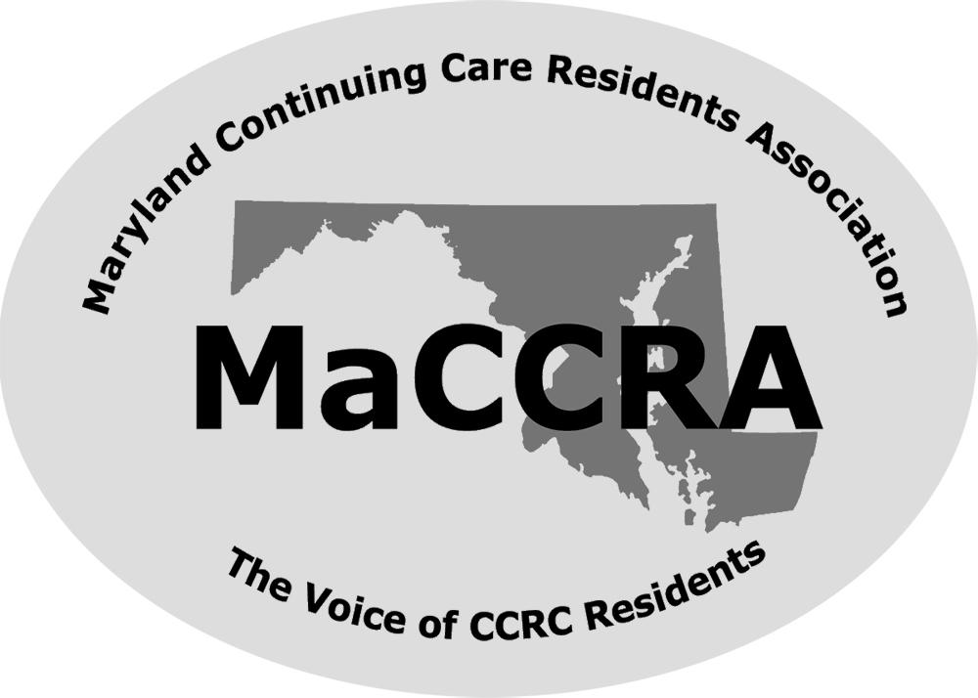 | Maryland Continuing Care Residents Association  Charlestown Chapter  Membership 2019-2020
Thank you for your support last year through your membership.
The Charlestown Chapter celebrates the start of our third year with over 90 residents as members. MaCCRA celebrates 25 years as a statewide association with 17 chapters and over 2,000 members. This June the Charlestown Chapter hosted a successful state meeting with the help of MaCCRA Chapter members.
MaCCRA continues to serve as your advocate in the General Assembly and with the Department of Aging. Last year MaCCRA sponsored legislation to allow an attorney present if mediation is needed as part of the grievance procedure. Please renew your membership so that we can continue to support MaCCRA’s future legislative agendas.
For additional information, contact [add name, email, and phone number]. Make your check payable to: MaCCRA Charlestown Chapter and send it to [add name of treasurer and apt. number]. Renewal is $20 per individual / $30 per couple.
CUT HERE AND RETURN WITH PAYMENT:
Name 1:
Name 2:
Apt:
Phone:
Email Address 1:
Email Address 2

