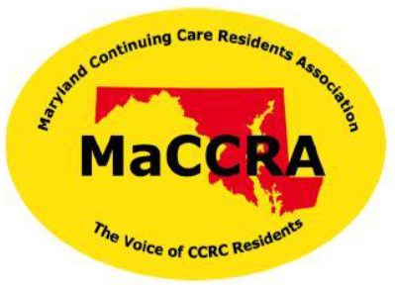

Maryland Continuing Care Residents Association
TODAY:
What Every Resident Should Know About MaCCRA
What: IKF Chapter Annual MaCCRA Meeting
Where: Cultural Arts Center – Baltimore Room
When: 11:00 AM – Noon
Guest Speakers: [add names]

Bring your Membership Dues Form & check to join.

