Who is Looking Out for You?
Join
MaCCRA
Maryland Continuing Care Residents Association
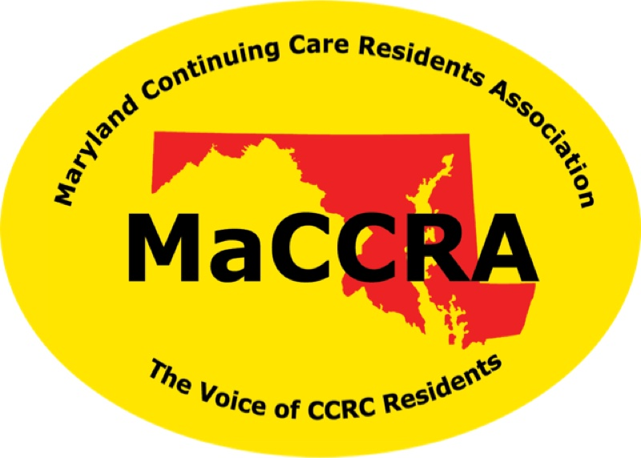
The only organization which is solely dedicated to
protecting and advancing the interest of residents of
continuing care retirement communities (CCRCs).

MaCCRA
- Protects and improves the rights and financial security of residents via legislative and regulatory change.
- Encourages cooperation between residents and management.
- Employs a registered lobbyist to assist with the legislative program.

- Educates and informs members regarding ongoing activities through chapter and annual meetings.
- Conveys resident desires to the Maryland Legislature, Maryland Department of Aging, Health Department, Governor’s Office
- Is an organization of individual members and chapters (20 or more members in a CCRC).
Contact [add Name and phone] for membership information.

