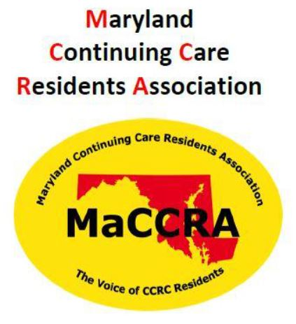
All IKF Residents Encouraged to
Join MaCCRA Again this Year
By John Patrick, President,
IKF MaCCRA Chapter
The Maryland Continuing Care Residents Association (MaCCRA) protects and advances the interests of residents of Continuing Care Retirement Communities (CCRCs), such as Ingleside at King Farm, including support of beneficial legislation and regulations. The state MaCCRA organization also retains a Legislative Liaison in Annapolis for educational and monitoring purposes relating to residents’ interests. IKF’s MaCCRA Chapter officers attend various statewide meetings in Annapolis and at other CCRCs to learn of current developments affecting the rights of residents at CCRCs (also now known as Life Plan Communities) in Maryland. Thus, your annual MaCCRA membership helps protect our rights and interests as Ingleside residents.

For more information on MaCCRA, you can visit their website: https://maccra.org or for the national CCRC residents organization: https://naccra.com. Please join our local IKF Chapter by completing the form on the last page and turning it in to the Front Desk for the MaCCRA-IKF collection envelope.

We request receipt of your renewal or new memberships prior to our annual meeting this year on Thursday, October 3rd. We will again discuss important legal protections that MaCCRA has helped to accomplish, provide key facts about our MaCCRA Chapter, and elect our Chapter officers. The proposed slate this year consists of: John Patrick as President, Gary Welsh as Vice President, Dorothy Welsh as Treasurer, and Barbara Gressman as Secretary/IT/Membership Coordinator. In addition, nominations from the floor can be made for any of the positions.

We are also working with MaCCRA officials and coordinating with Management here to host at IKF the MaCCRA statewide semi-annual meeting this coming December.

Please complete the membership form on the last page of this issue of the Insider, then separate and fold it with your tax-deductible dues check made out to “MaCCRA-IKF” and return them to the MaCCRA envelope at the Front Desk. Thank you.

