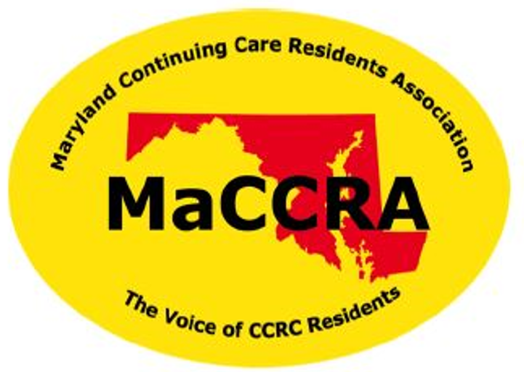
Please Join MaCCRA for FY20 Membership
Maryland Continuing Care Residents Association

MaCCRA is the only organization that is solely dedicated to protecting and advancing the interests of residents of Continuing Care Retirement Communities (CCRCs) in Maryland, such as our Ingleside at King Farm home. We invite you to join or renew your membership with MaCCRA for fiscal year 2020 (7/1/19 to 6/30/20) to help protect our resident rights and financial security at IKF.
MaCCRA is a 501(c)(3) tax-exempt nonprofit organization, and your paid annual dues are tax deductible to the full extent permitted by law. Any additional tax-deductible donations are also always welcome.
Please make your check payable to “MaCCRA-IKF” and turn in your check with this completed form to the MaCCRA envelope at the Front Desk.

Please support MaCCRA this year!
Apt: _______ Name(s): _______________________________________________
Annual Dues (check one): _____ $20 for Individual _____ $30 for Couple
Additional Donation (optional) of $ ______________
Your cancelled check is your receipt for tax records. If you would like an additional receipt from the IKF Chapter Treasurer, check here ______.

