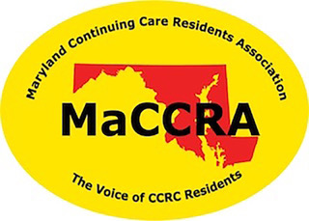
MaCCRA - The only statewide organization that represents your interests as a resident living in a CCRC (continuing care retirement
community or life plan community).

MaCCRA - Instrumental in the passage of legislation that provides protection for your investment.

MaCCRA - Continues to work to protect your investment in your CCRC through the legislative and regulatory process.

MaCCRA - Retains a professional legislative liaison or lobbyist to help in that effort.

MaCCRA - 17 CCRCs throughout Maryland belong to the MaCCRA association.

Please Join! Numbers count in the political arena!

MARYLAND CONTINUING CARE RESIDENTS ASSOCIATION

