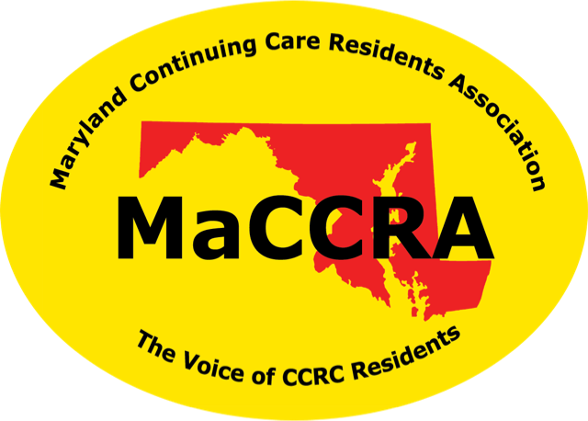

**M**aryland**C**ontinuing**C**are**R**esidents**A**ssociation

**The Voice of Continuing Care Residents**

**Your Name, President**

**Address**

[**email**](mailto:Alma-bob@comcast.net) **•** [**phone**](tel:(410)%20329-1199)