Maryland Continuing Care Residents Association
The Voice of Continuing Care Residents

Ann MacKay, MaCCRA President
717 Maiden Choice Ln., Apt. 511
Catonsville, MD 21228
ann.mackay@gmail.com Cell: (443) 542-8282
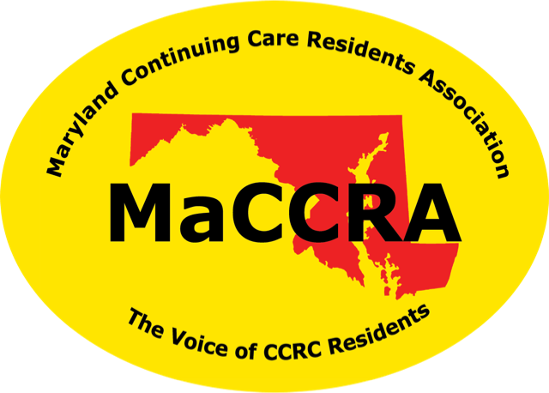

Maryland

____________________________________________________________

MaCCRA Semi-Annual Meeting Notice
Saturday, December 7, 2019 – 10:00 a.m. – 2:00 p.m.

LOCATION: Ingleside at King Farm (IKF) Retirement Community
Center for Healthy Living - Cultural Arts Center
Entrance on King Farm Blvd. Entrance on Piccard Dr. (New)
701 King Farm Blvd. 1615A Piccard Drive
Rockville, MD 20850 Rockville, MD 20850

DETAILS: There is a limit of 100 people in the Cultural Arts Center Meeting Room. There will be an initial limit of 4 officers/delegates for Registrations by November 15th. Additional members from your chapter can be included after that date, space permitting (per amendment of by-laws).

A continental breakfast and lunch will be provided. Cost is $22 per member - send one Chapter check for total members attending. Include their names, email addresses and any dietary restrictions. A separate check can be issued for those additional attendees approved after the November 15th deadline.

DEADLINE: November 15, 2019. Make check payable to “MACCRA-IKF.” Mail check to Dorothy Welsh, Chapter Treasurer, 701 King Farm Blvd., Apt. 144, Rockville, MD 20850. For questions about additional attendees, you can email her at dwwelsh5@aol.com .
PARKING: Street parking is available in the front of the 701 Building along King Farm Blvd. It is not restricted on Saturdays. Additional parking is available on the sides of the Building and behind near the Center for Healthy Living, as well as on Piccard Dr. there. However, you also may park in the new Ingleside parking lot near the new addition (Center for Healthy Living) and enter the Building from the door off that parking lot, which is very close to the meeting room. For those who have difficulty walking distances, the new parking lot will be a much better choice. To get to the parking lot, drive West on King Farm Blvd. past the Main Ingleside entrance. Turn Right just past the Ingleside Building (sign for Center for Healthy Living). Turn Right again into the parking lot. The official address of the new back entrance is 1615A Piccard Dr., but we are not sure it is appearing on Google maps yet.

CHECKIN: Upon arrival, check in at the Concierge Desk inside either entrance. You will be directed to the Registration Desk for the meeting.
Welcoming continental breakfast starts by 10:00 am in the Cultural Arts Center (Annapolis-Baltimore rooms).
DIRECTIONS: From the South and East (from I-495 Beltway): Take I-270 N to Exit 8 – Shady Grove Rd, follow sign to Shady Grove Rd., turn right onto Shady Grove. Proceed to 2nd traffic light (Gaither Rd.) and turn Right. Continue on Gaither Rd. and go to the 2nd traffic light, King Farm Blvd., turn Right. IKF at 701 King Farm Blvd. is the large yellowish-beige building on the Right.

From the North (Baltimore area): Take I-95 S to Exit 31B for the Inter County Connector (ICC) MD-200 West toll road (EZ Pass only). Take Exit 2 Frederick Ave. (Rte. 355 S) (off I-370 Sam Eig Highway extension Rd.) going South. Turn left onto Rte. 355. Go about ¾ mi. to King Farm Blvd. Turn Right and go about 1 mile to IKF (large yellowish-beige building on the right). OR take I-95 South (by-pass the ICC) to Exit 27 for I-495 Beltway West and follow the directions above from the South.

From the North (Frederick Area, North of Shady Grove Rd.): Take I-270 S to Exit 8 – Shady Grove Rd. Turn Left on Shady Grove Rd. and go to 3rd traffic light, turn Right on Gaither Rd. Continue on Gaither to King Farm Blvd. Turn Right. IKF is the large yellowish beige building the Right.

Registration Form: Return by Nov 15th to Dorothy Welsh, 701 King Farm Blvd., Apt 144, Rockville, MD 20850. Include a single check to MaCCRA-IKF.
Community Name:
Last Name: | First Name: | Position in Chapter: | Phone: | Email: | Dietary Restrictions:
Total @ $22 per person

Additional Requests (space permitting) | For Community Name:
Last Name: | First Name: | Position in Chapter: | Phone: | Email: | Dietary Restrictions:
Total @ $22 per person

