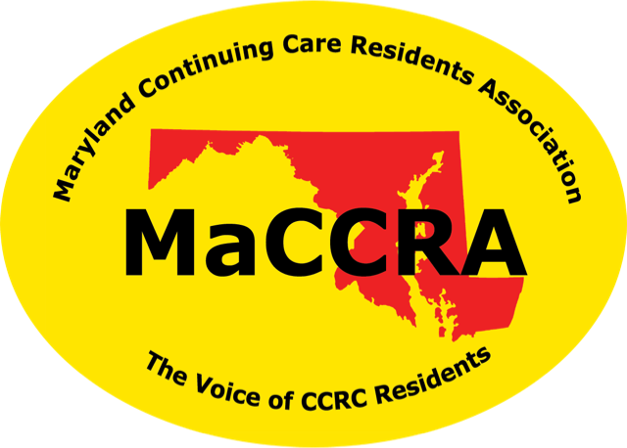

**M**aryland**C**ontinuing**C**are**R**esidents**A**ssociation

**The Voice of Continuing Care Residents.**