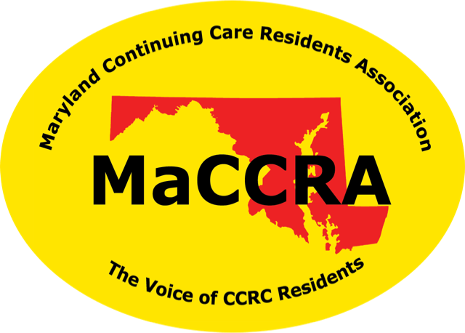
Maryland Continuing Care Residents Association

The Voice of Continuing Care Residents.

MEMBERSHIP RENEWAL

Now is the time for renewal of MaCCRA dues for 2017-18. If you are not a member, please join this organization which is your VOICE IN ANNAPOLIS. MaCCRA is the only organization solely dedicated to protecting and advancing the interests of residents of Continuing Care Retirement Communities (CCRCs) in Maryland.

Dues have remained the same for over twenty years and are:

Single member $20 Couples $30

MaCCRA is a 501(c)3 organization and dues are tax deductible.

If you joined MaCCRA after April 1, 2017, you do not have to pay again until July 2018.

Write your check to Broadmead-MaCCRA and include it with this notice indicating:

Name:_____________________________ Apt. No.____________

Place your check with this notice in:

MESSAGE BOX G-10,

ETHEL LANDIS, MaCCRA Treasurer

